Contents

Introduction 2

Data 3

Methodology 4

Exploratory Data Analysis 4

GeoJson data: 4

Foursquare data: 4

Creation of the mesh of points 4

Foursquare request 6

Population data 8

Inferential statistical testing 8

Machine Learning Techniques used 9

Results 10

Health 10

Transport 10

Well-Being 11

Dailyneeds 11

Education 12

All categories cluster: 12

Conclusion 13

Introduction

With over 6 million people living in 33 different boroughs, London is the capital of the United Kingdom and one of the most important financial cities in the world. As you can imagine, whenever any family needs to move into London, or just want to relocate within the city, the decision is not easy: Not all of the neighbourhoods have the same access to services or places. Some areas could have really good transportation links however they may not be close enough to supermarkets or grocery shops. Some others could have extraordinary access to hospitals and or doctors but may not have any park, or school for the kids in the family near to them.

The target audience of this analysis is a young family with children that has to make the decision of which area of London is going to be next place to his new home and it is aimed to provide enough good information about each of the 33 boroughs of the London metropolitan Area to help in the decision making process.

We would like to classify each boroughs of the London metropolitan area based on the population and the number of services that each borough has into main categories such as: Transportation, Health Services, Education, Well-Being and Daily needs that are considered the most relevant for the target audience.

Data

To do the analysis a number of online sources in conjunction with Foursquare location data can be used. The details of them are as follows:

* **Population Data of the UK by Authority Area**

This can be found online in Web from the Office for National Statistics of the British Government (<https://www.ons.gov.uk/>). The link is: <https://www.ons.gov.uk/peoplepopulationandcommunity/populationandmigration/populationestimates/datasets/populationestimatesforukenglandandwalesscotlandandnorthernireland> In the file we can find the spreadsheet MYE2 - Persons with the estimates of the British population by Authority area of 2019.

Each row of the data represents one Authority Area of UK (in the case of the London Metropolitan Area, the file will have a row for each of the neighbourhoods or boroughs of London) The columns represents the number of people living in 2019 for each age. There is also a column with the Total that is the one that we are interested in.

In the file we can see that each Authority Area has a code. The codes for the 33 London boroughs are the ones Starting in E09000001 and ending in E09000033

* **GeoJson file with the boundaries of all district areas for the UK**

This can be found online in the British Government data portal <https://data.gov.uk/>

The link to the particular GeoJson File is: [http://geoportal1-ons.opendata.arcgis.com/datasets/fab4feab211c4899b602ecfbfbc420a3_3.geojson?outSR={%22latestWkid%22:4326,%22wkid%22:4326}](http://geoportal1-ons.opendata.arcgis.com/datasets/fab4feab211c4899b602ecfbfbc420a3_3.geojson?outSR=%7B%22latestWkid%22:4326,%22wkid%22:4326%7D)

This file is providing the boundaries of each Authority Area (borough or neighbourhood) for the whole United Kingdom. For each area we can see the name, the code of the neighbourhood (the same as in the population data file) and the geometry of the area by points (Longitude, Latitude) of the boundary

* **Foursquare location data** for all the venues within the London Metropolitan Area of the next types: Hospital, Doctor, Pharmacy, Train Platforms, Underground, Light Rail, Park, Pool, Gym, Fruit and Vegetable shop, Supermarket, Shopping mall, Elementary School, Middle School and Preschool*.*

Methodology

# Exploratory Data Analysis

## GeoJson data:

The data obtained from the British government provides all the boundaries of all British Local Authority Areas. Since the analysis is focused in London a modification in the file is needed dropping all the areas that are not within London metropolitan Area. In future, this new file will be used to exclude any venues that are outside London and to display the chlorophet map with only the boroughs in the analysis

## Foursquare data:

The objective is to obtain all the venues of the selected categories that are inside the London metropolitan Area. The challenge in this is the limits in number of requests and number of venues in the results that Foursquare set for free accounts. A Foursquare request, centred in the centre of London with a radius large enough to cover all the metropolitan area and with all the categories we are interested could be used, however only 50 venues would be retrieved due to Foursquare limits. To ensure that all the venues of each category are retrieved from the Foursquare database a sweep of the London metropolitan area with circles of a radius small enough to not saturate the request with over 50 results is used. Going further a sweep of the area looking for venues of only one particular category is done. In that way the number of sweeps to the London metropolitan area will match exactly the number of distinct types of venues that the target audience of the analysis are interested in.

### Creation of the mesh of points

Foursquare only allows to get venues by giving it a centre and a radius. In this way we need to create a mesh of points (Longitude, Latitude) that will be used as centres in the Foursquare request and that will cover the entire area of all London neighbourhoods. The layout of circles that will cover the area with less overlapping zones is similar to the one in the next picture.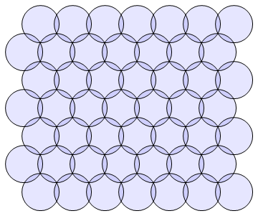

The distance between the centre of each circle in function of the radius are defined by the next expressions:

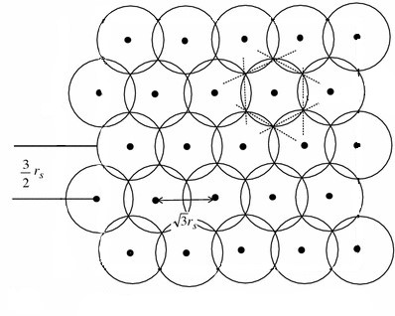

Once the distance between points is known we only need to define where to place the mesh. The answer to that lies with the GeoJson data from the previous step: by checking what are the minimum and maximum values of the coordinates longitude and latitude of the geographical points defining the boundary of all the neighbourhoods of London we obtain the 4 vertex of the rectangle that set the boundaries of the mesh.

The next picture shows the mesh obtained:

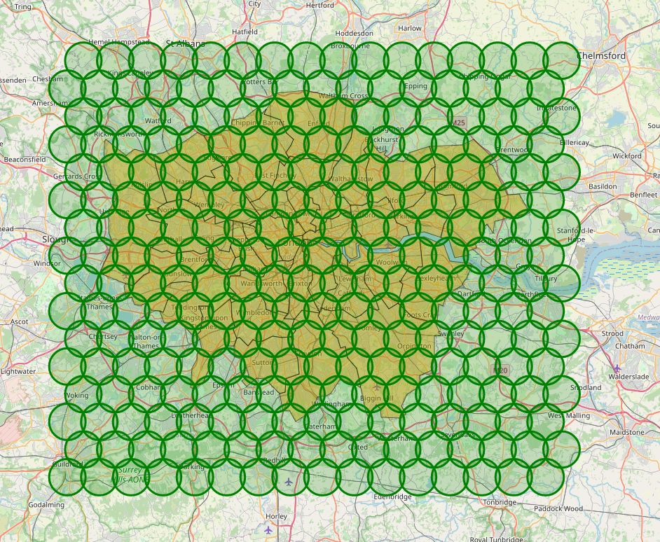

As we can see we cover the whole area of London, however there are a number of circles that are entirely out of any London area. The next step is to remove them from the mesh as this will lead to requests to Foursquare API that will not bring useful data for our analysis. The resulting mesh of points is displayed in the next figure:

To get rid off the circles a check in 6 points of the its circumference is used to discard any circle with all the 6 points out of London.

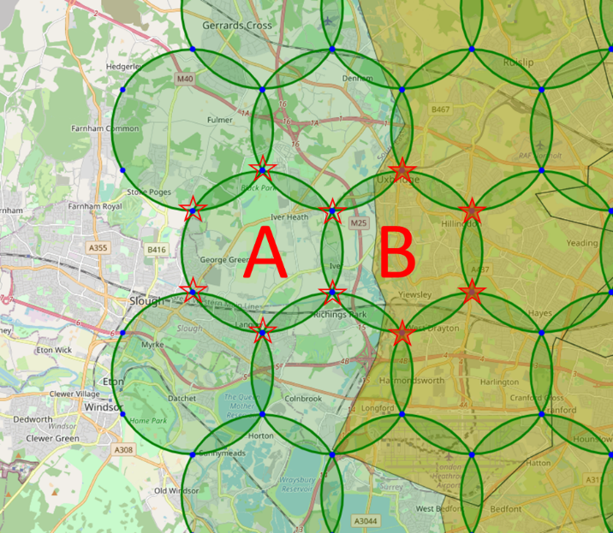

Circle A is removed from the mesh as none the 6 points belongs to London area. Circle B is kept as 4 points fall under London area.

The next image shows the final mesh obtained:

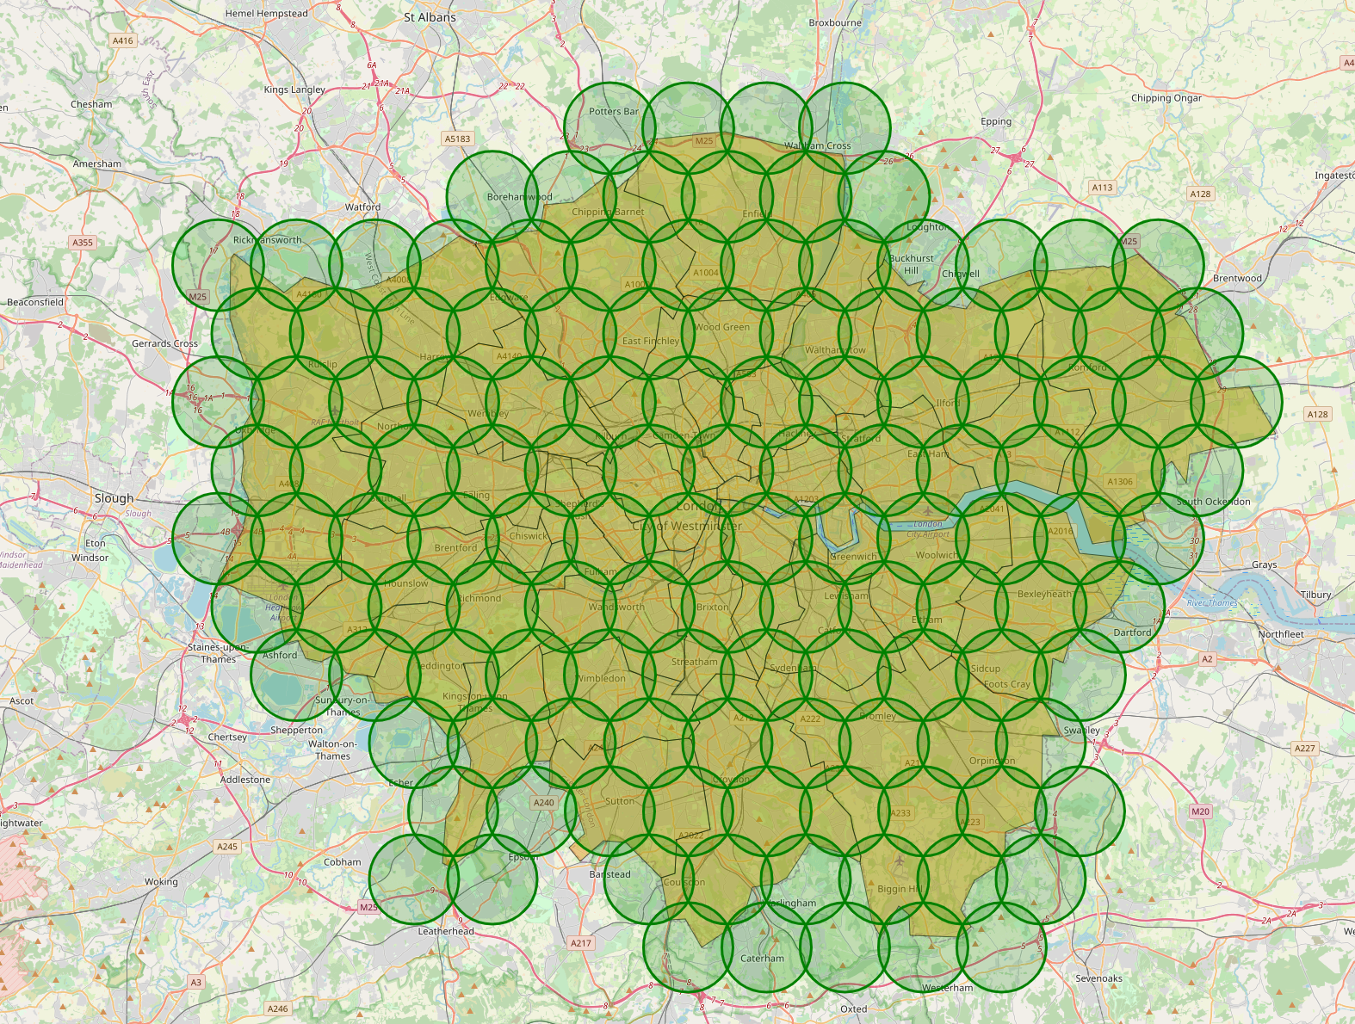

### Foursquare request

In total 15 different venues categories have been selected for the analysis. They all fall into the main groups that are considered the lead for the project that can be see next including the Foursquare venue category code. This piece of information has been obtained from the Foursquare documentation (<https://developer.foursquare.com/docs/build-with-foursquare/categories/>)

Health:

Hospital: 4bf58dd8d48988d196941735

Doctor: 4bf58dd8d48988d177941735

Pharmacy: 4bf58dd8d48988d10f951735

Transport:

Train Platforms: 4f4531504b9074f6e4fb0102

Underground: 4bf58dd8d48988d1fd931735

Light rail: 4bf58dd8d48988d1fc931735

Well-Being:

Park: 4bf58dd8d48988d163941735

Pool: 4bf58dd8d48988d15e941735

Gym: 4bf58dd8d48988d175941735

Daily needs:

Fruit and Vegetable shop: 52f2ab2ebcbc57f1066b8b1c

Supermarket: 52f2ab2ebcbc57f1066b8b46

Shopping Mall: 4bf58dd8d48988d1fd941735

Education:

Elementary School: 4f4533804b9074f6e4fb0105

Middle School: 4f4533814b9074f6e4fb0106

Preschool: 52e81612bcbc57f1066b7a45

As already mentioned, the way to obtain all the venues of each category from Foursquare will be 2 nested loops, The first one across categories and the second one across all the points in the mesh.

As there are 130 points in the mesh and 15 categories, the number of requests needed is 130 x 15 = 1950. As Foursquare has a limit of 500 calls an hour and 950 calls a day. The exercise of obtaining the venues is done across 3 different days. The results obtained for each category are saved in a csv file. Once all the csv files from the 3 different days are created, they are all combined in 1 data frame.

The data retrieved from Foursquare for each venue are the name, geographical coordinates (Long, Lat) and venue category. At this moment we are still missing the neighbourhood that the venue belongs to. To identify it, we will use the GeoJson file created in previous step and define a function that given a point and the GeoJson return the name and code of the neighbourhood.

All the data is stored in a pandas dataframe with 8788 relevant venues and 6 columns

They can be all seen in the next map:

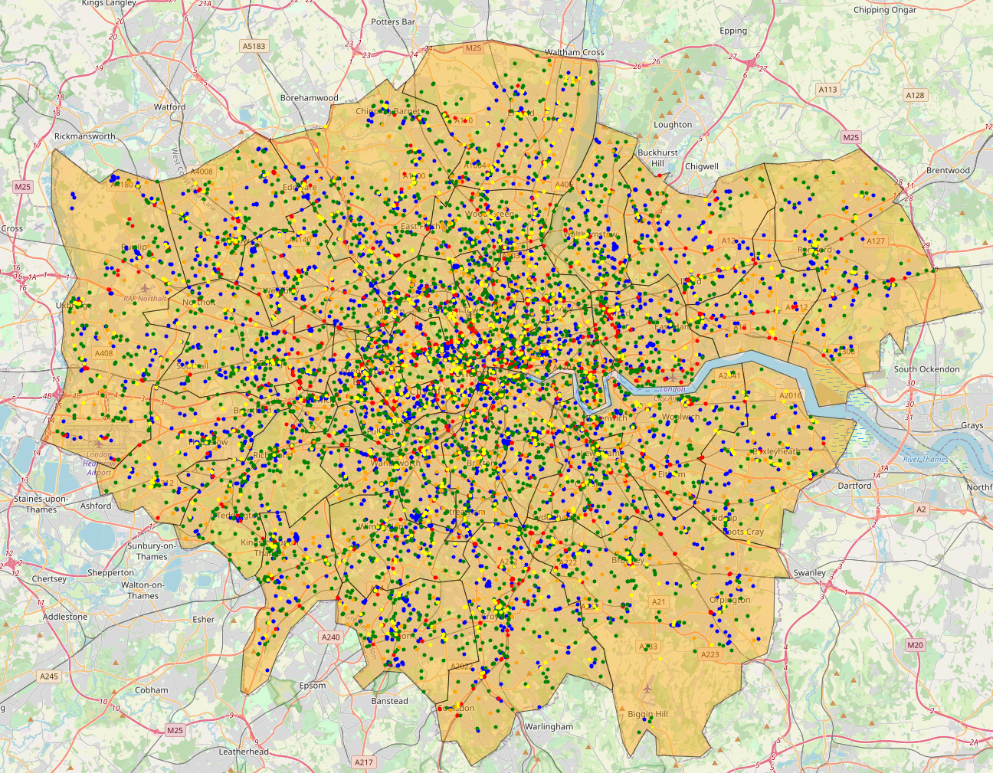

The final step is to pivot the data to obtain how many venues of each category there are in each of the boroughs.

## 

## Population data

The Excel file obtained from the Office for National Statistics of the British Government contains the number of people that are estimated to be living in each Local Authority Area of the United Kingdom. In this case the methodology is to update the file into a pandas dataframe and keeping only the date for the London Boroughs. A choropleth map can be filled showing the amount of people living in each area.

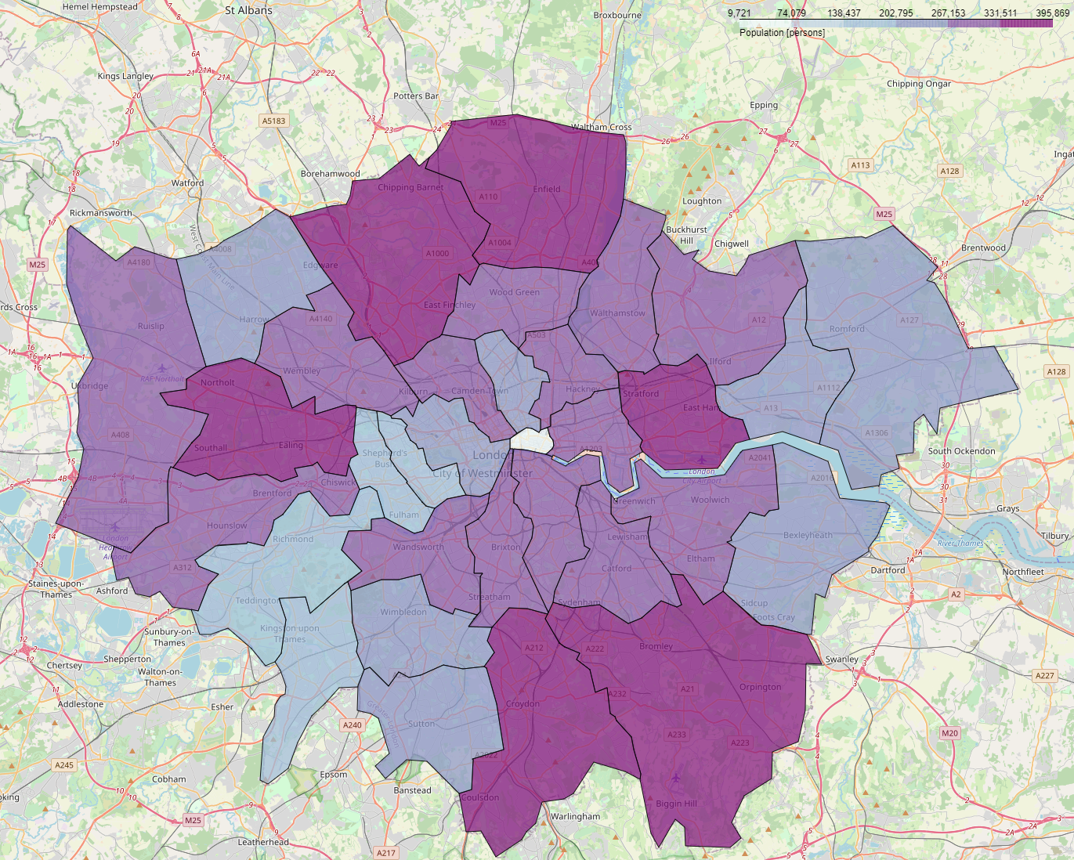

Now we are in a position to obtain the number of venues of each type by 1000 inhabitants in each of the boroughs. This is the metric that is going to be use to compare neighbourhoods

# Inferential statistical testing

To understand better how are the values of each ratio [venues per 1000 inhabitants of each type] a boxplot using the Seaborn library is used. This will allow to visualize the mean, the quartiles and min and max values for each of our ratios is displayed. The result of the analysis is shown in the next figure.

We can see there are bigger differences between boroughs when we look at how many hospitals per 1000 people are in it. Gyms and Train platforms have also a big variance between neighbourhoods. All of them can make a big difference when deciding to live in one place or another.

On the other side, the number of Light trains, shopping malls and middle schools do not have a big range between the max and the min, therefore the impact when choosing a borough over other is not as important.

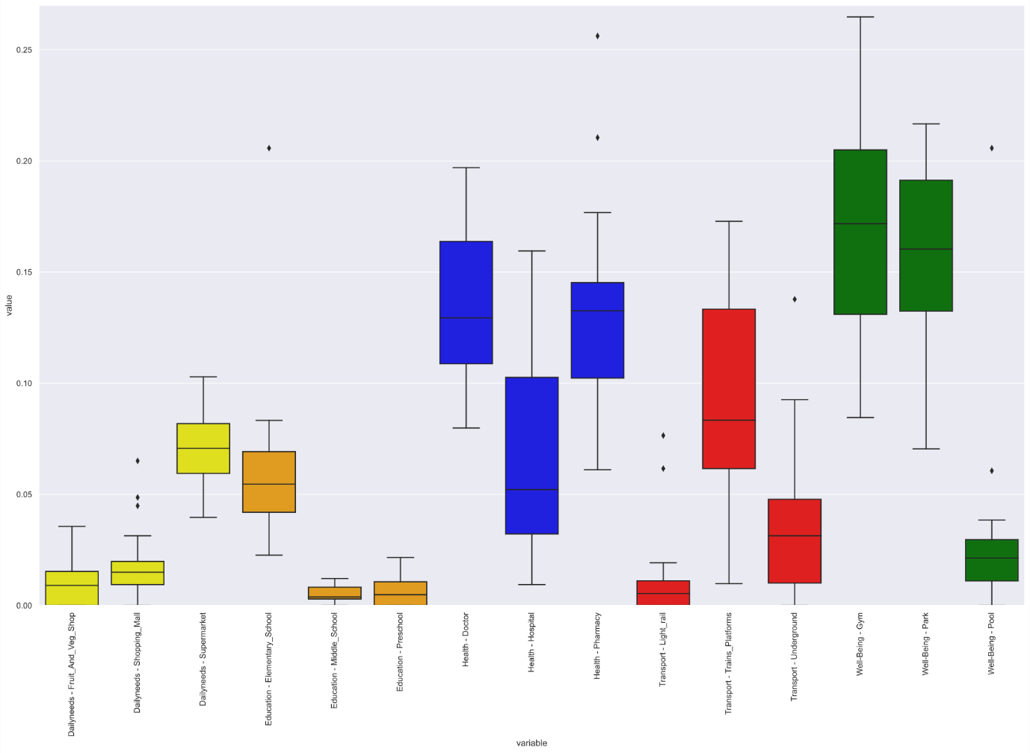

# Machine Learning Techniques used

In order to group similar neighbourhood, I have decided to use *k-means clustering*. Its simplicity makes it the perfect grouping technique for this purpose. As we are going to run several times (one for each group, and another with all the categories) it will be computationally faster.

Results

## Health

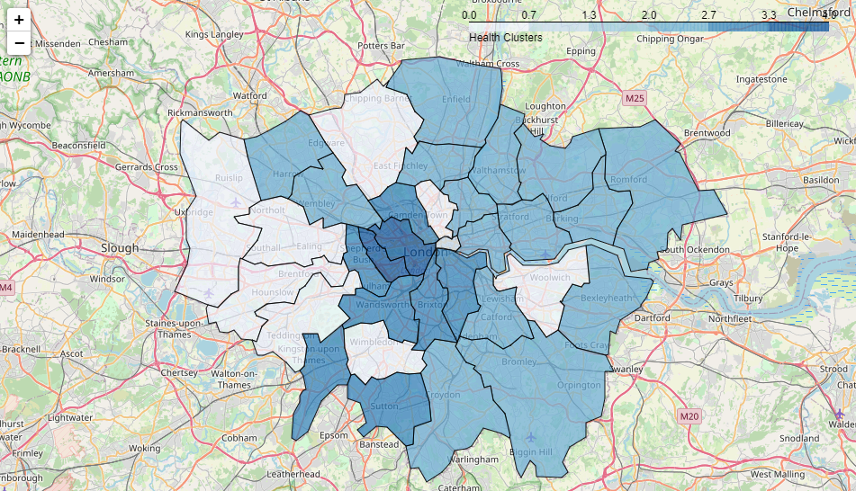

## Transport

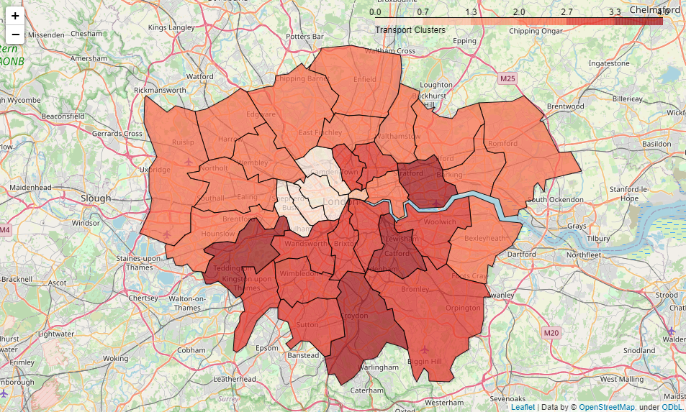

## Well-Being

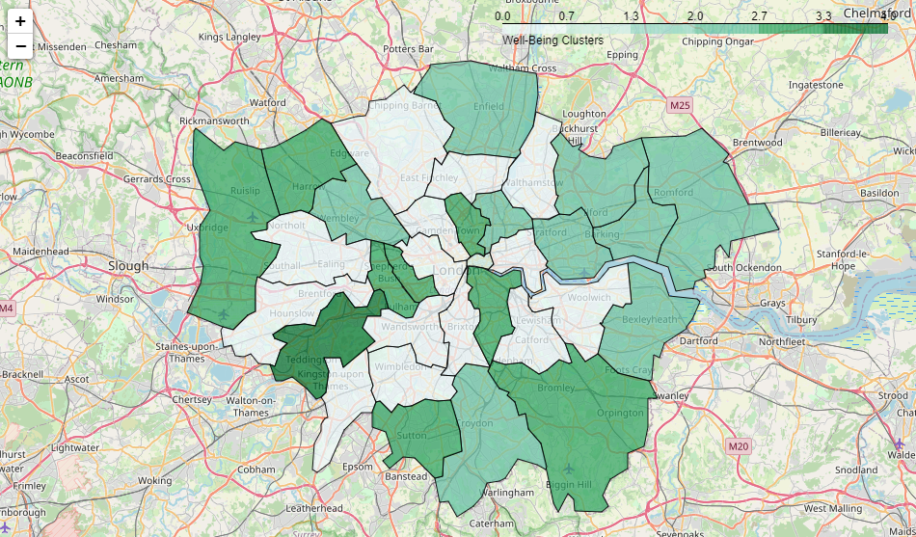

## Dailyneeds

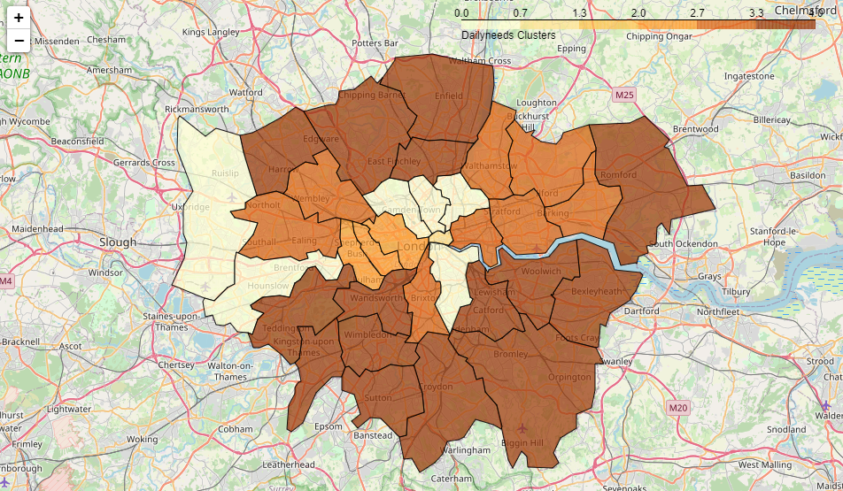

## Education

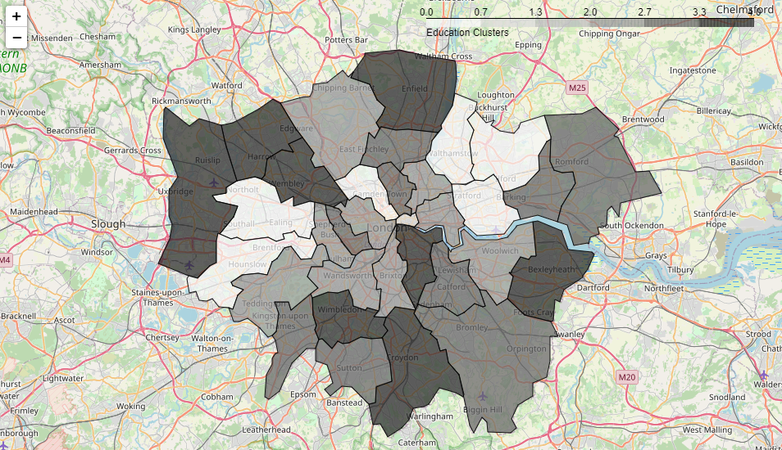

## All categories cluster:

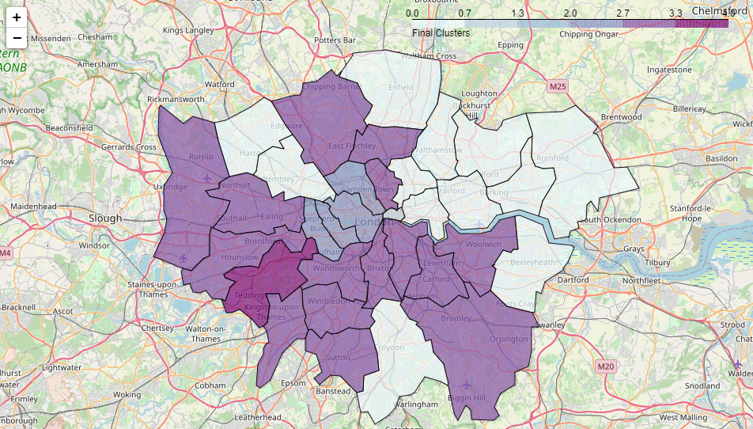

# Conclusion

There are 2 boroughs in London that could consider unique with no other similar to the:

In the centre of the city, the borough “City of London”, the smallest one of all of them is characterised for having the highest ratios of almost all venues per 1000 inhabitant.

“Richmond upon Thames” cannot be clustered with any other borough. Its main characteristics is a well rounded in all areas being in most of the ratios in the average or well above it.

There is another are in the centre of the metropolitan area of 4 boroughs with similar ratios overall in particular the health and transports ones where they are over the average.

In the average on almost all the ratios is the south and some areas in the north such as “Barnet”, “Islington” and “Haringday”

To conclude all the neighbourhoods in the north of the metropolitan area fall under the same category where the ratios in general are the lowest ones.